1. a screenshot of Rstudio

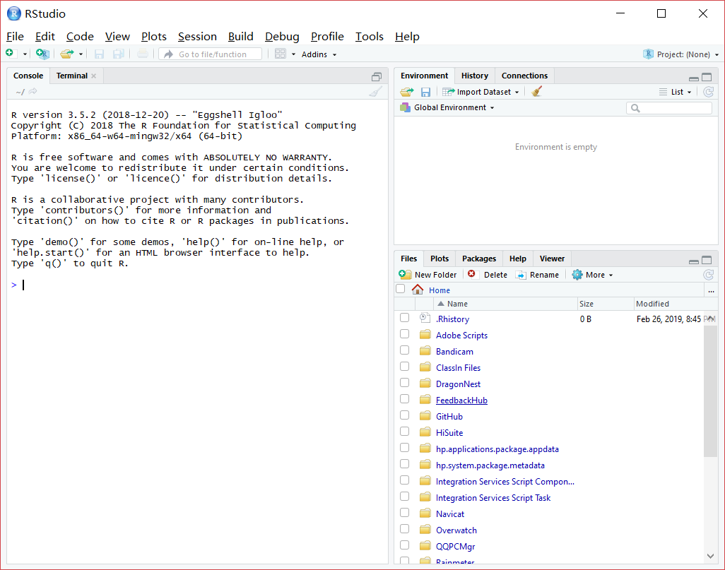

1. https://github.com/519772745/introdatascience
2. <https://github.com/519772745/introdatascience/blob/master/HelloWorld.md>
3. https://github.com/519772745/courses